**Sales Performance Analysis**

DESCRIPTION

Background

Mike Goodman, the head of Product Management of a retail products company, is responsible for determining which products his company should continue to offer for sale and which products should be discontinued from the company’s product catalog.

Objective

To build a dashboard that will present monthly sales performance by product segment and product category to help client identifying the segments and categories that have met or exceeded their sales targets, as well as those that have not met their sales targets.

Analysis Tasks

1. Use the Saved Sample – Superstore dataset.
2. Create a bullet chart with Category and Segment dimensions and Sales measures.
3. Blend the data with the Saved Sample - Sales Target data set to bring in the Sales Target measure.
4. Color code the chart to identify Categories and Segments that are above or below target.
5. Add the year of sales to the view to identify trends and outliers.
6. Add a filter so that the user can select one, more than one, or all years.
7. Create a dashboard with this view.

This the tableau woksheet where the Calculation are done.

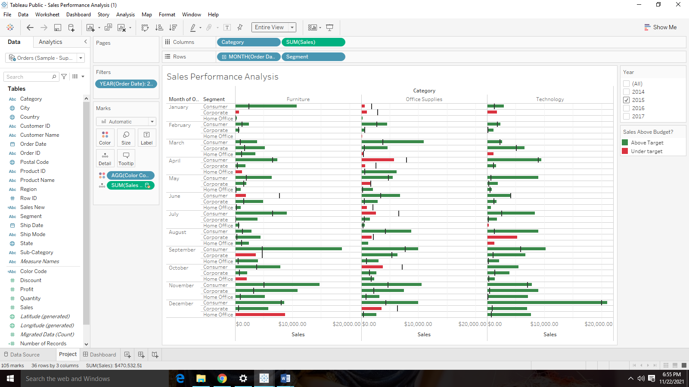

This is the Dasboard created from the sheet of the Tableau.

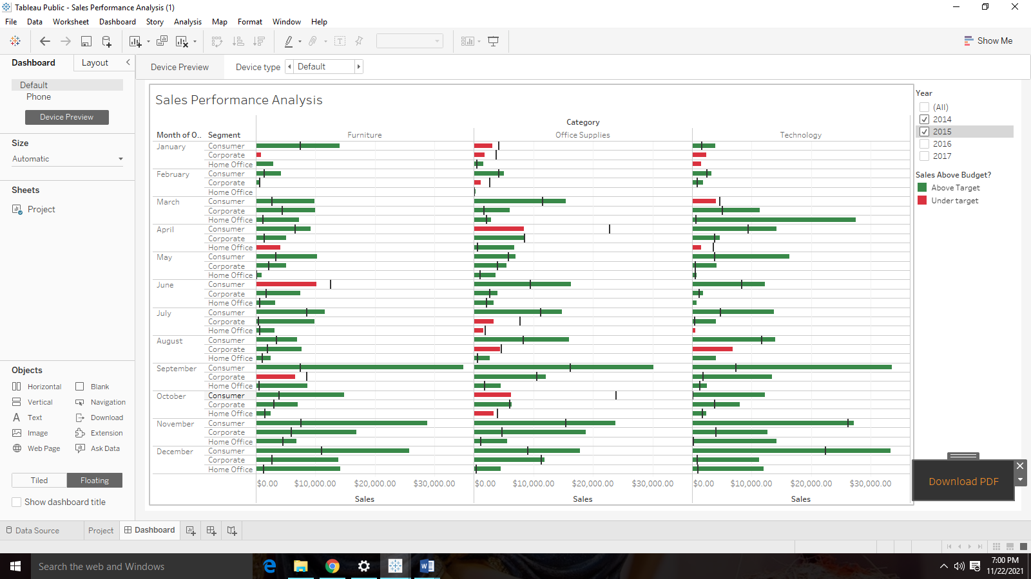

Link for the Tableau Public: <https://public.tableau.com/app/profile/mrinmay.saha/viz/SalesPerformanceAnalysis_16542581210650/Dashboard?publish=yes>

Conclusion: From this dashboard user filter out the year and find out the sales of the respective category and segment and also find out if the sales are about above the target sales or not.